**­­­**

Class 7

**Lecture 8**

**Web & Internet**

**Internet in Daily Life**

**Internet**

**&**

**Web**



**Lab Objectives:**

* Internet in Daily Life.

**Uses of the Internet in our Daily Life**

1. **Uses of Internet in Students daily life**

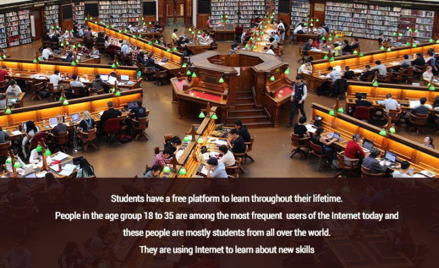

Students have a free platform to learn throughout their lifetime. People in the age group 18 to 35 are among the most frequent users of the Internet today and these people are mostly students from all over the world. They are using the Internet to learn new skills and even acquire degrees in professional online courses. Similarly, educators like us are using the Internet for teaching and sharing our knowledge and experience with the world. There are many websites which help to explore what your hidden potential is and which profession would suit you the best.

1. **Uses of Internet to increase the speed of daily tasks**

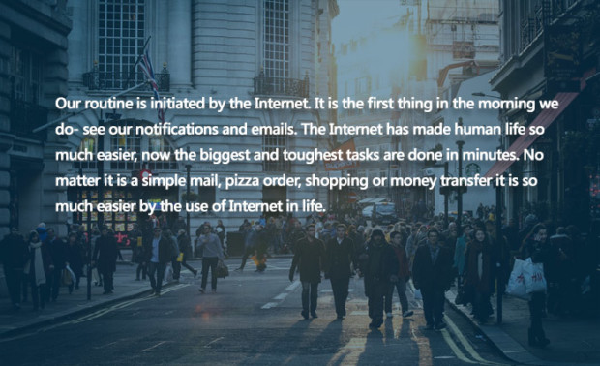

Our routine is initiated by the Internet. It is the first thing in the morning we do- see our notifications and emails. The Internet has made human life so much easier, now the biggest and toughest tasks are done in minutes. No matter it is a simple email, pizza order, shopping or money transfer it is so much easier by the use of the Internet in life.

1. **Uses of the Internet for business promotion and innovation**

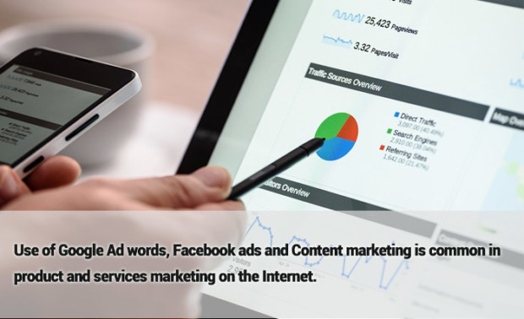

We also use the Internet to promote our business. We can sell our products by using various e-Commerce solutions on the Internet. E-commerce is booming on the Internet and we can see new services and creative business starting up every single day, which in turn is creating jobs and thereby reducing unemployment.

Use of Google Ad words, Facebook ads, and content marketing is common in product and services marketing on the Internet. People are always looking for the ways on the Internet to grow their business.

1. **Uses of Internet for shopping in our daily life**

Shopping on the Internet is affordable, convenient and saves time. The Use of flipkart.com, alibaba.com, amazon.com, paytm.com, snapdeal.com etc. for online shopping is common. That’s how the Internet is affecting our shopping habits in daily life.

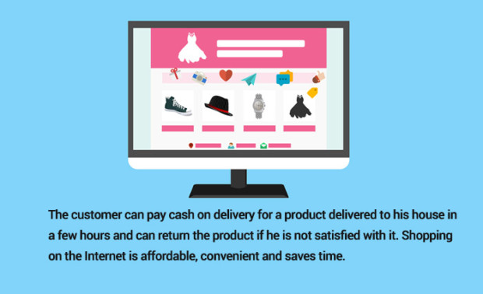

1. **Use of Internet for research and development**

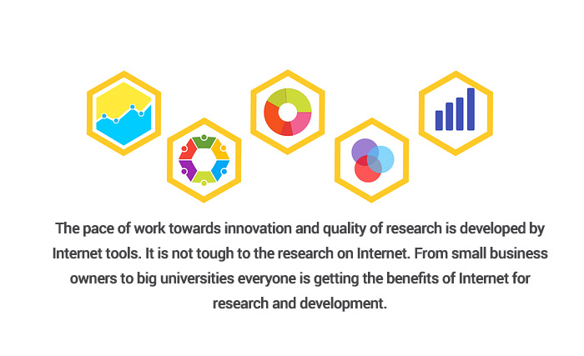

Any information we need regarding science ,arts, health, money, law, RTI etc. everything is in front of us within a few seconds. So, it is really important that we use the power of the Internet for practical benefits.

1. **Use of Internet provide us quick and free communication**

This ability to communicate at breakneck speeds enables us to finish our tasks faster and become more efficient.

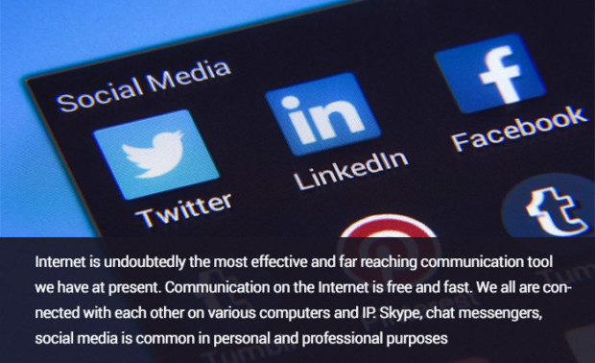

1. **Uses of Internet for Teaching and Sharing**

The Internet is a very important tool for educators. The Internetand its application are user-friendly and make students life easy.

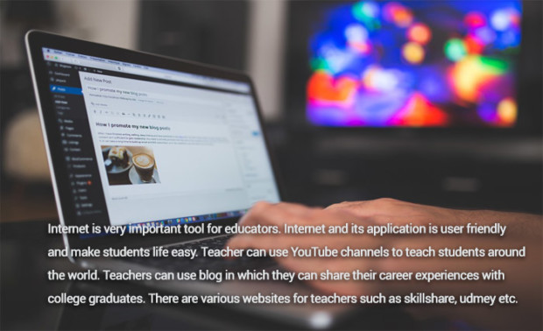

A teacher can use YouTube channels to teach students around the world. Teachers can use the blog in which they can share their career experiences with college graduates. There are various websites for teachers such as Skillshare, udmey,slideShare etc

1. **Uses of internet for parents**

Not all parents are computer and the internet literate. But the internet literate people can use the internet to guide their kids.

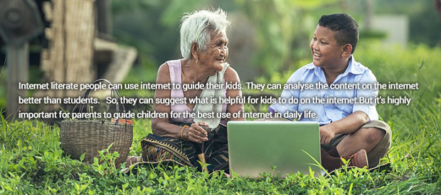

They can analyze the content on the internet better than students. So, they can suggest what is helpful for kids to do on the internet. Another thing is that they can help kids in their studies and education.

1. **Government policies and schemes are easily accessible by the use of Internet**

The right utilization of Internet power is challenging for governments across the world. Government expenses are reduced due to providing data and information for people on the government websites. People are taking advantages of Government policies and websites. Any government information and service are easily accessible for the citizens. Using tools such as Right to Information, we can have online access to important government documents.

